

BETTER EDUCATIONAL CONSULTANCY
PRE-PRIMARY LEAVING EXAMINATION
SET THREE, 2022
SCIENCE
Time Allowed: 2 hours 15 minutes
Random No. |  |  |  |  |  |  | Personal No.
Index No.

Candidate’s Name: ……………………………………………………………………….………………
Candidate’s Signature: …………………………………………………………………………………
School Random No. ……………………………………………………………………….………………
District ID: …………………………………………………………………..…………………………………
Read the following instructions carefully:
FOR EXAMINER’S USE ONLY

Qn. No | MARK | EXR’S NO.
1 – 10
11– 20
21 – 30
31 – 40
41 – 43
44 – 46
47 – 49
50 – 52
53 – 55
TOTAL

1. Do not write your school of district name
anywhere on this paper.

2. This paper has two sections: A and B.
Section A has 40 questions and section B has
15 questions.

3. Answer all questions. All answers to both
sections A and B must be written in the
spaces provided.

4. All answers must be written using a blue or black
ball point pen or ink. Any work written in pencil
will not be marked.

5. Unnecessary changes in your work and handwriting
that cannot be easily read may lead to loss of marks.

6. Do not fill anything in the table indicated:
ʺfor examiner’s use only˝ and boxes
inside the question paper.

©2022 Better Educational Consultancy
Tel: 0779101164, 0750558616, 0706602422, 0775157214. Turn over
1. Name one source of current electricity.
_____________________________________________________________________
2. Which vector spreads yellow fever to people?
____________________________________________________________________
3. State any one use of a tooth paste in promoting personal hygiene.
____________________________________________________________________
4. Give any one example of a chemical change in living things.
______________________________________________________________________
5. Which group of warmed blooded vertebrates reproduce by laying eggs?
______________________________________________________________________
The diagram below shows parts of a human skeleton. Use it to answer question 6 and 7.
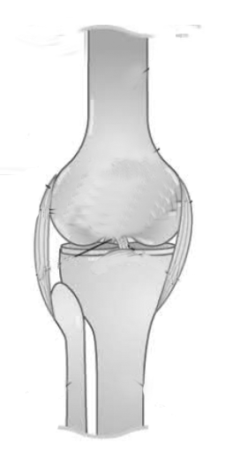

Q

P

6. Name the structure marked Q.
________________________________________________________________________
7. What is the function of the part marked P?
________________________________________________________________________
8. State the type of goats kept for their hair.
________________________________________________________________________
9. What type of objects do not allow all the light to pass through them?
________________________________________________________________________
10. Why do people use clay soil for modeling?
________________________________________________________________________
11. How is wax in the ear of human beings important?
___________________________________________________________________
12. Write down one way of caring for crops in a nursery bed.
________________________________________________________________________
13. State any one characteristic of molar teeth which makes them suitable for their
function.
___________________________________________________________________
14. How can breeding of mosquitoes be controlled apart from draining stagnant water?
_______________________________________________________________________
15. Which deficiency disease causes soft and weak bones?
________________________________________________________________________
The diagram below shows a worm. Study it and answer questions 16 and 17.
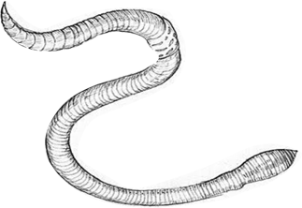

16. Name the worm shown in the diagram above.
________________________________________________________________________
17. How is this worm useful to people in the environment?
________________________________________________________________________
18. State any one characteristic of laboratory manufactured drugs.
________________________________________________________________________
19. Give any one way you can conserve the home environment.
________________________________________________________________________
20. How do plants benefit from the sun?
________________________________________________________________________
21. State one characteristic of renewable resources.
________________________________________________________________________
22. Give any one function of blood plasma.
________________________________________________________________________
23. State any one way in which having enough rest and sleep is important to the human body.
________________________________________________________________________
24. How is a mango adapted to animal dispersal?
________________________________________________________________________
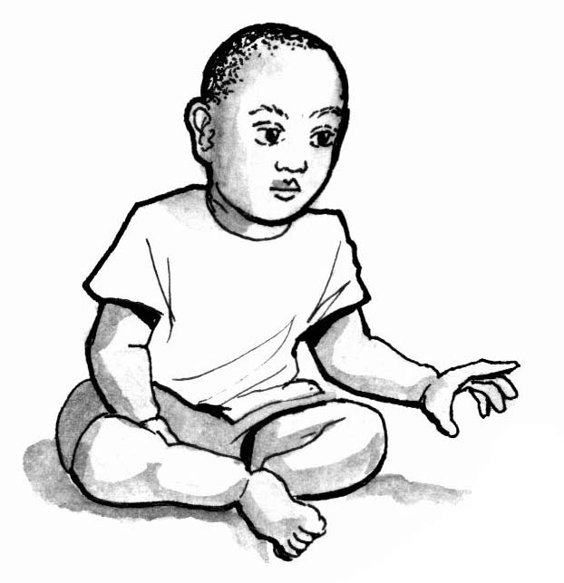
The diagram shows a boy warming himself on a cold day.

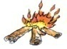

Fire wood
Boy

25. Name the energy change when the wood burns to give fire.
________________________________________________________________________
26. By what means does the heat from the fire reach the boy?
________________________________________________________________________
27. Give one type of energy given off by the fire.
________________________________________________________________________
28. How does dipping a scald in cold water help the victim?
________________________________________________________________________
29. State the importance of the epiglottis during breathing.
________________________________________________________________________
30. Which water borne disease affects the liver?
________________________________________________________________________
31. Apart from income, give any one other importance of table birds.
________________________________________________________________________
32. Which rabbit disease causes shivering, sneezing and difficulty in breathing?
________________________________________________________________________
33. Give one way in which electricity produced by dry cells can be increased.
________________________________________________________________________
34. How does a liquid behave when placed in a container?
________________________________________________________________________
35. State any one condition which is favourable for plants to make food.
________________________________________________________________________
36. Name any one vegetable crop which is propagated by use of stem cutting.
________________________________________________________________________
37. Which group of invertebrates have a body shell?
________________________________________________________________________
38. Apart from preventing STDs, give any one other advantage school children get
from PIASCY programme.
________________________________________________________________________
39. Give one way farmers preserve seeds for planting.
________________________________________________________________________
40. Name any one human organ that stores fats in the body.
___________________________________________________________________

SECTION B
41(a) Name the least component of air.
___________________________________________________________________
(b) Why are rare gases used to fill electric bulbs?
___________________________________________________________________
(c) Give one use of wind as an energy resource.
___________________________________________________________________

(d) How can dangers of wind be prevented in the environment?
___________________________________________________________________
42. The diagram shows the life cycle of an insect. Study it and answer questions that follow;
B
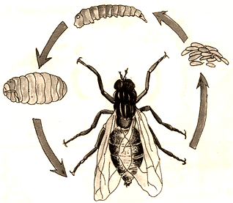
A
C

D

(a) Name one insect which has the type of life cycle shown above.
___________________________________________________________________
b) Which stage of this insect is more dangerous to people?
___________________________________________________________________
c) How is stage B different from stage C?
___________________________________________________________________
(d) What do we call this type of life cycle?
___________________________________________________________________
43. a) Write down any two causes of drowning.
i. ___________________________________________________________________
ii. ___________________________________________________________________
b) Give any two ways of avoiding drowning at home.
i. ___________________________________________________________________
ii. ___________________________________________________________________

44.a) Write any two reasons why bats are classifies as mammals.
i. __________________________________________________________________
ii. ___________________________________________________________________
b) In which two ways are bats different from birds.
i. ___________________________________________________________________
ii ___________________________________________________________________
45.a) Write down any two ways of collecting information from a health survey.
i. ___________________________________________________________________
ii. ___________________________________________________________________
b) Give two importance of a health survey to the government.
i. ___________________________________________________________________
ii. ___________________________________________________________________
46. In the table below, part A shows minerals and vitamins and part B has uses.
Part A | Part B
Iron  Calcium  Iodine  Vitamin C | Makes thyroxin  Prevents bleeding gums and improves skin  Makes bones and teeth strong  Makes blood cells.

Iron ________________________________________________________
Calcium ________________________________________________________
Iodine _____________________________________________________
Vitamin C _______________________________________________________
47. a) Give one example of an exotic breed of sheep kept in Uganda.
___________________________________________________________________
b) Name the meat got from sheep.
___________________________________________________________________
c) State any the diseases that commonly attack sheep.
i. ___________________________________________________________________
ii. ___________________________________________________________________
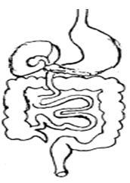
48. The diagram below is of part of the digestive system. Study it and use it to answer the questions.
R
Q

S

(a) Name the digestive juice produced in parts R and S.
i. R: _______________________________________________________________
ii. S: _______________________________________________________________
b) Give the importance of the digestive juice produced by part Q.
___________________________________________________________________
c) Which part of the digestive system is not part of the alimentary canal?
___________________________________________________________________
49.a) State any two ways in which mulching cam improve soil fertility.
i. ___________________________________________________________________
ii. ___________________________________________________________________
b) State any two disadvantages of mulching to a crop farmer.
i. _______________________________________________________________
ii. ___________________________________________________________________
50.a) To which type of simple machines does an axe belong?
___________________________________________________________________

b) State any one use of an axe
___________________________________________________________________
(c) How can the efficiency of an axe be improved to make work easier?
___________________________________________________________________
(d) Give one other example of a machine which belongs to the same group as an axe.
___________________________________________________________________
51.a) State any two ways of promoting sanitation in a classroom
i. ___________________________________________________________________
ii. ___________________________________________________________________
b) Give any two diseases that can break out in a school due to poor personal hygiene.
i. ___________________________________________________________________
ii. ___________________________________________________________________
52. The diagram below shows a process of finding the volume of a stone. Study the diagram and answer the questions that follow.

25 cc
20 cc
15 cc
10 cc
5 cc
0

a) Name the containers marked P and K.
(i) P _______________________________________________________________
(ii) K _______________________________________________________________
b) What is the volume of the stone?
___________________________________________________________________
c) What method of solving a problem is shown by the experiment?
___________________________________________________________________
53.(a) What type of venation does a maize plant have?
________________________________________________________________________
b) Name the type of root system found in Maize.
___________________________________________________________________
c) Which type of roots does maize develop during the fruiting period?
___________________________________________________________________
d) To which group of flowering plants does maize belong?
___________________________________________________________________
54. a) Give one way in which soil is formed.
___________________________________________________________________
b) State any two properties of loam soil.
i. ___________________________________________________________________
ii. ___________________________________________________________________
c) Write down one way of controlling soil exhaustion.
___________________________________________________________________
55.a) What is the importance of bees to a crop farmer?
___________________________________________________________________
b) Give the importance of a honey chamber in a modern bee hive.
___________________________________________________________________
c) What so we call the breathing organs on the abdomen of a queen bee?
___________________________________________________________________
d) State the life cycle of a honey bee.
___________________________________________________________________
END.

